Architecture

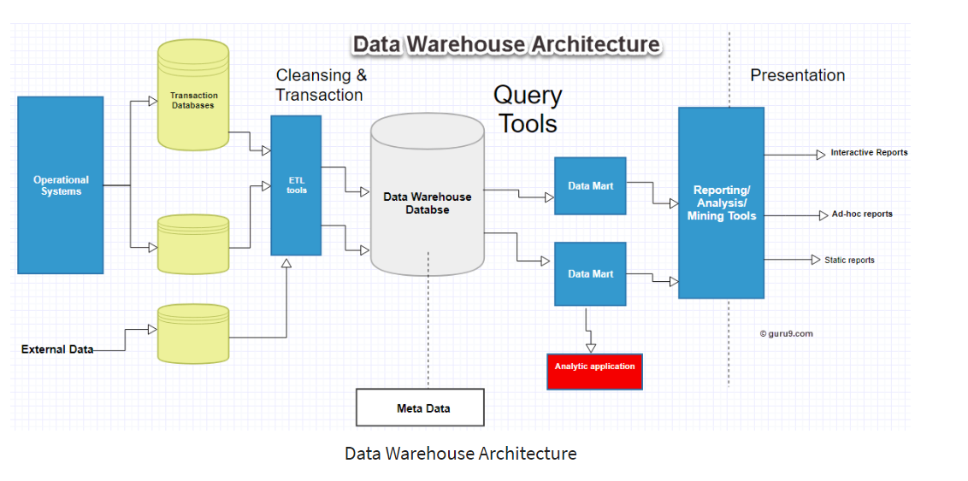

Before processing the data ie cleaning the data if there is a mistake within the process then entire data needs to be regenerated from the operating system via all mode ie csv,json,nosql object,external data etc.
So to avoid this there is a place called as Staging area in Data WareHouse where all the data are collected are stored before cleaning dataset using etl tools.
E Extract
T Transform
L Load

